Project Design Phase – II
Data Flow Diagram & User Stories

Date | 11 february2026
Team ID | LTVIP2026TMIDS67435
Project Name | Weather-Based Prediction Of Wind Turbine Energy Output:  A Next-Generation Approach To Renewable Energy Management
Maximum Marks | 4 Marks

Data Flow Diagrams (DFD)
A Data Flow Diagram (DFD) represents how weather data, turbine parameters, and prediction models interact within the AI-based wind energy forecasting system. It shows how data enters the system, how it is processed, stored, and how predictions are generated.
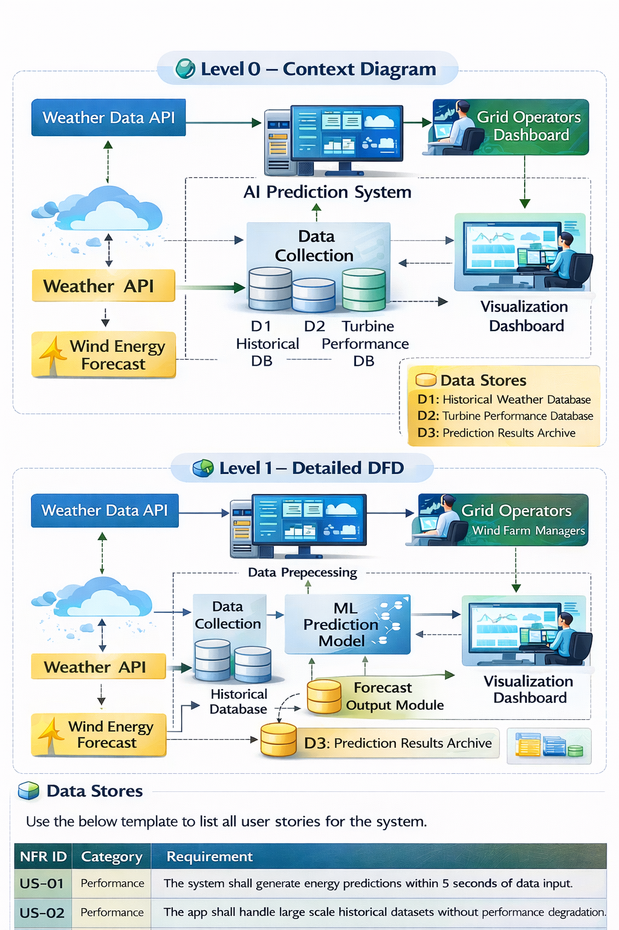
User Stories
Use the below template to list all user stories for the system.
User Story ID | Epic / Module | User Story (As a… I want… so that…) | Priority | Acceptance Criteria | Task Examples
US-01 | Data Integration | As a system admin, I want to integrate real-time weather API so that predictions are accurate. | High | Weather data updates automatically every hour. | - Integrate Weather API - Validate data format
US-02 | Prediction Engine | As a wind farm operator, I want accurate energy forecasts so that I can plan power generation. | High | Forecast accuracy above 85%. | - Train ML model - Evaluate accuracy
US-03 | Dashboard | As a grid operator, I want a visual dashboard so that I can monitor energy output easily. | High | Graphs update in real-time. | - Build charts - Connect backend API
US-04 | Historical Analysis | As an energy analyst, I want historical comparison charts so that I can analyze trends. | Medium | Historical data displayed with filters. | - Create filter UI - Connect database
US-05 | Storage Optimization | As a storage manager, I want predicted surplus alerts so that I can manage battery storage efficiently. | High | Alert triggered when output exceeds threshold. | - Add alert logic - Configure thresholds
US-06 | Grid Stability | As a grid operator, I want overload warnings so that I prevent power failures. | High | Warning generated before overload occurs. | - Add load balancing logic - Notification system
US-07 | Reporting | As a government energy board member, I want automated reports so that I can track renewable performance. | Medium | Monthly report auto-generated. | - Create PDF report - Schedule automation
US-08 | Model Improvement | As a data scientist, I want model performance metrics so that I can improve prediction accuracy. | Medium | Display RMSE, MAE metrics. | - Add evaluation module - Store metrics

